Binomial Expansion- Mark Scheme
June 2019 Mathematics Advanced Paper 1: Pure Mathematics 1

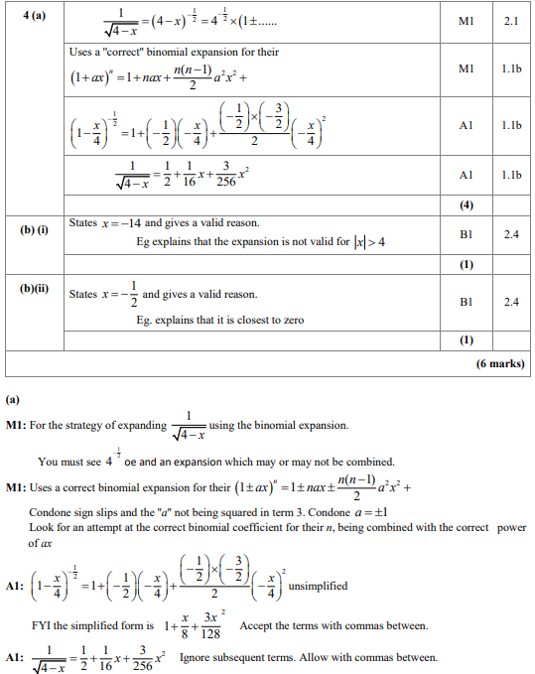

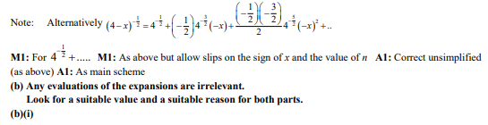
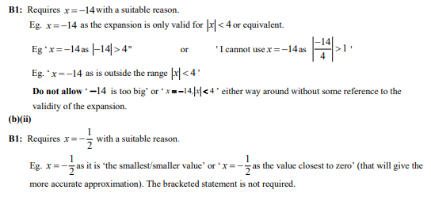

June 2018 Mathematics Advanced Paper 1: Pure Mathematics 1

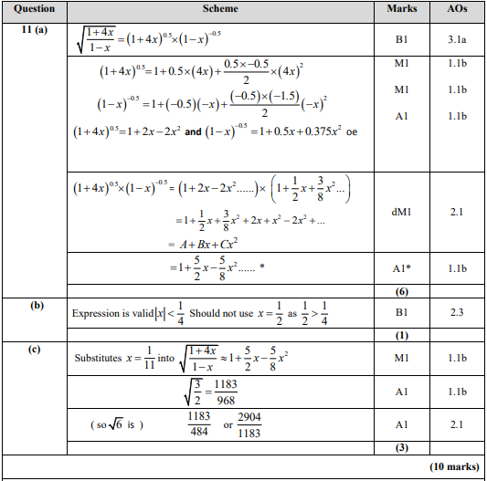
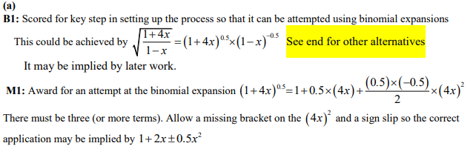
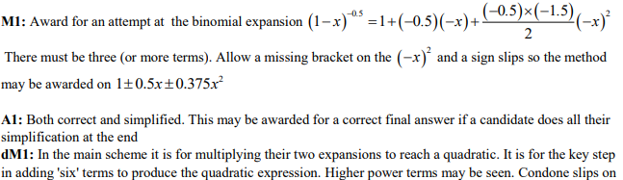
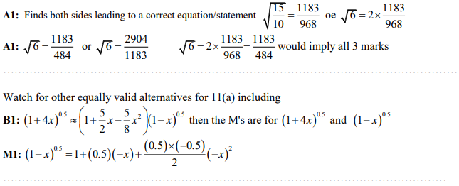
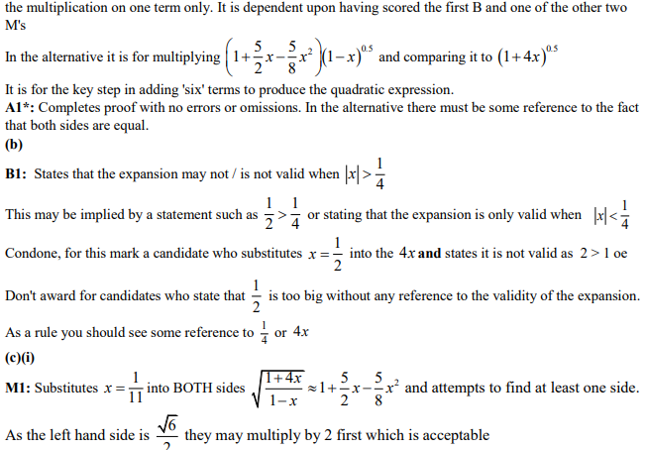

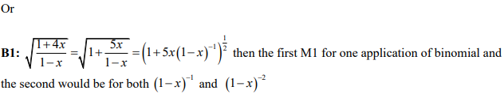
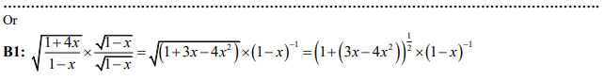
May 2019 Mathematics Advanced Paper 1: Pure Mathematics 1

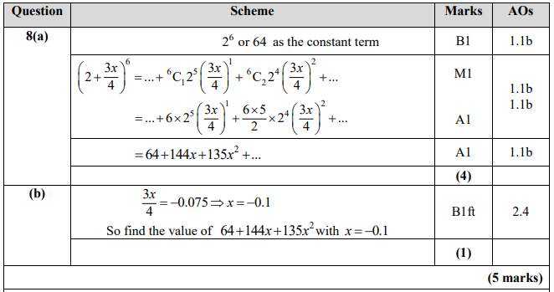
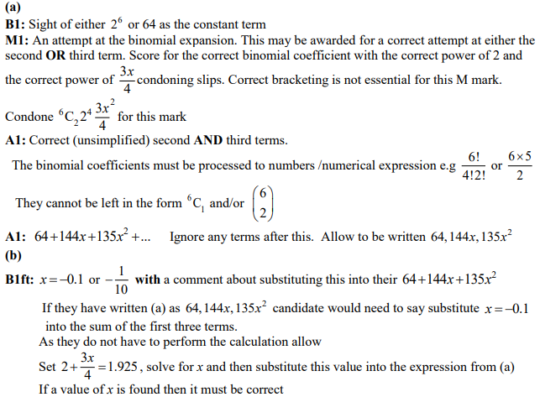
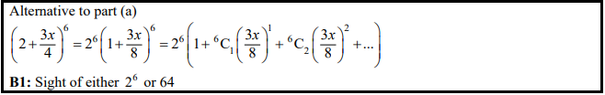
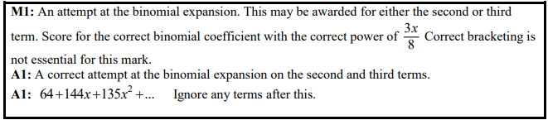

May 2018 Mathematics Advanced Paper 1: Pure Mathematics 1

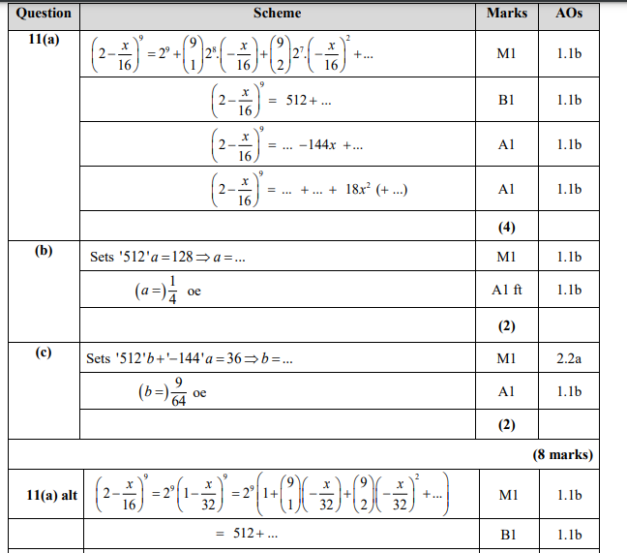
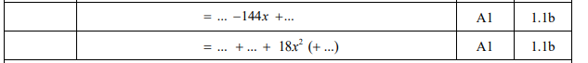
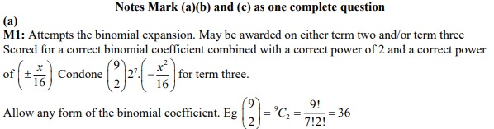
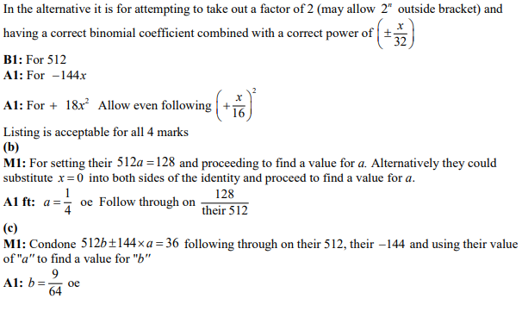

May 2017 Mathematics Advanced Paper 1: Pure Mathematics 2

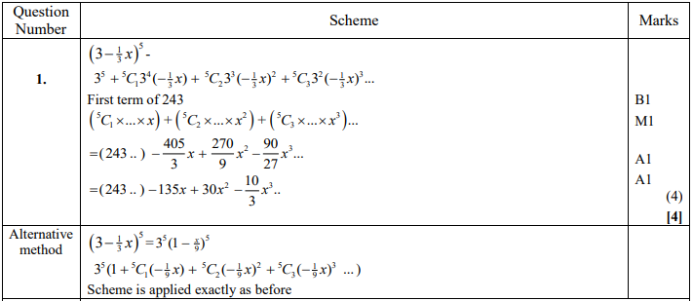
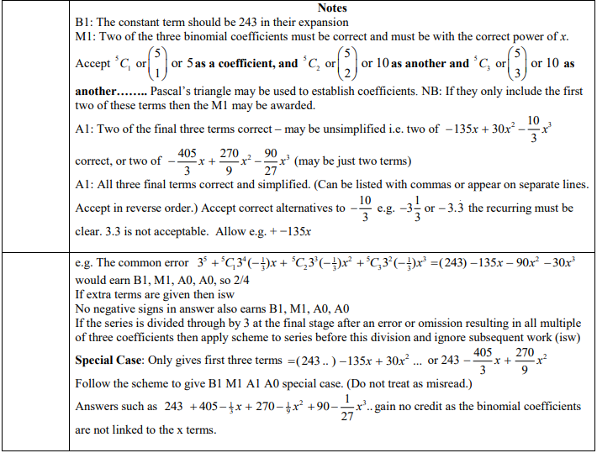
May 2015 Mathematics Advanced Paper 1: Pure Mathematics 2

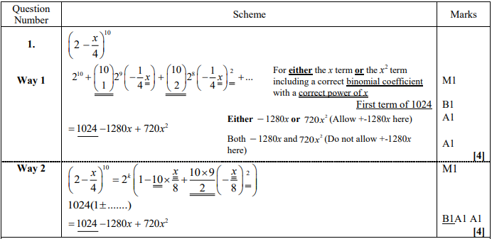
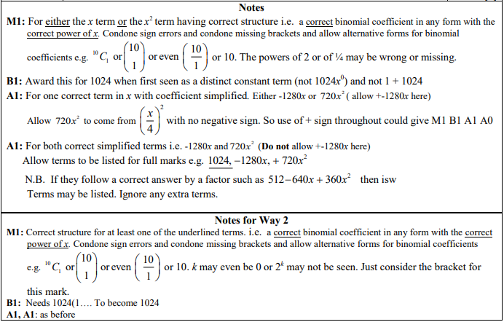

Jan 2013 Mathematics Advanced Paper 1: Pure Mathematics 2

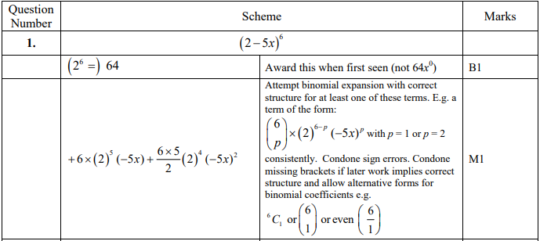
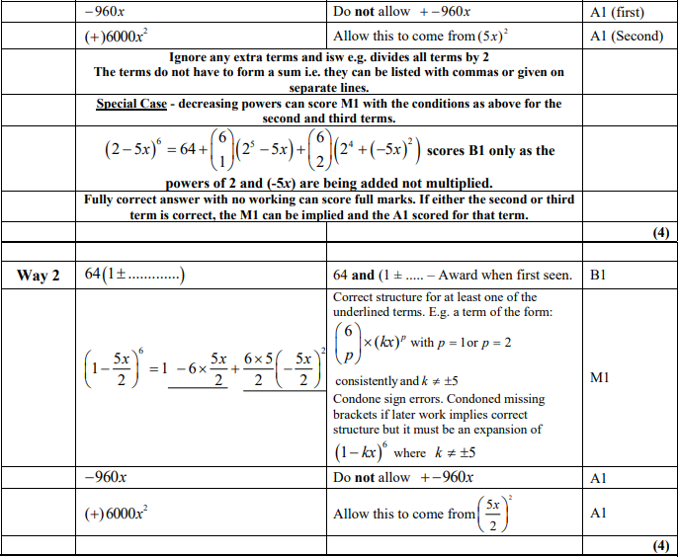

May 2012 Mathematics Advanced Paper 1: Pure Mathematics 2

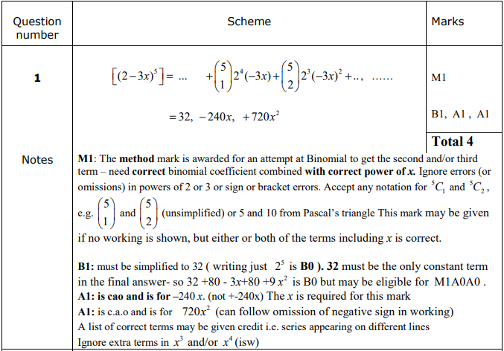
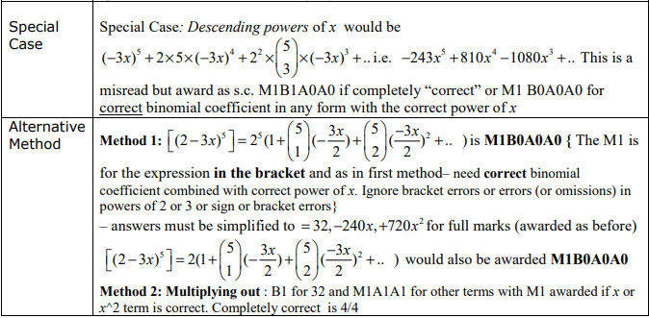

Jan 2010 Mathematics Advanced Paper 1: Pure Mathematics 2

